Installing Git for SSH (Windows)

1. Navigate your browser to git-scm.com and press the Downloads for Windows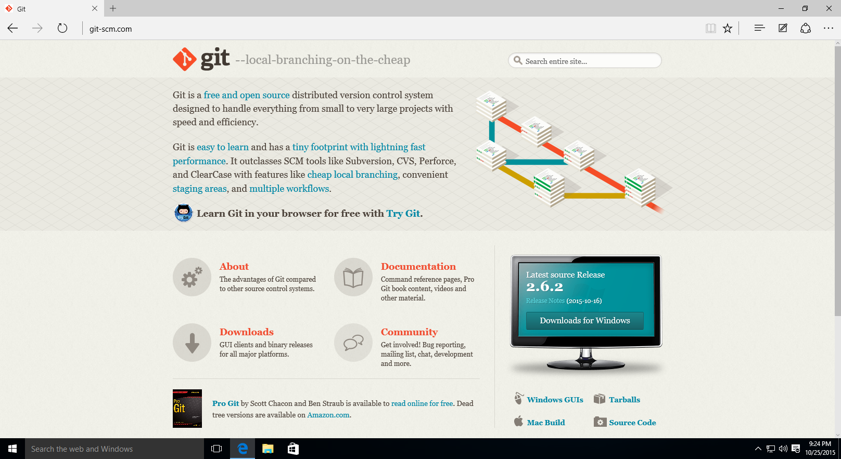
2. Wait for the download to finish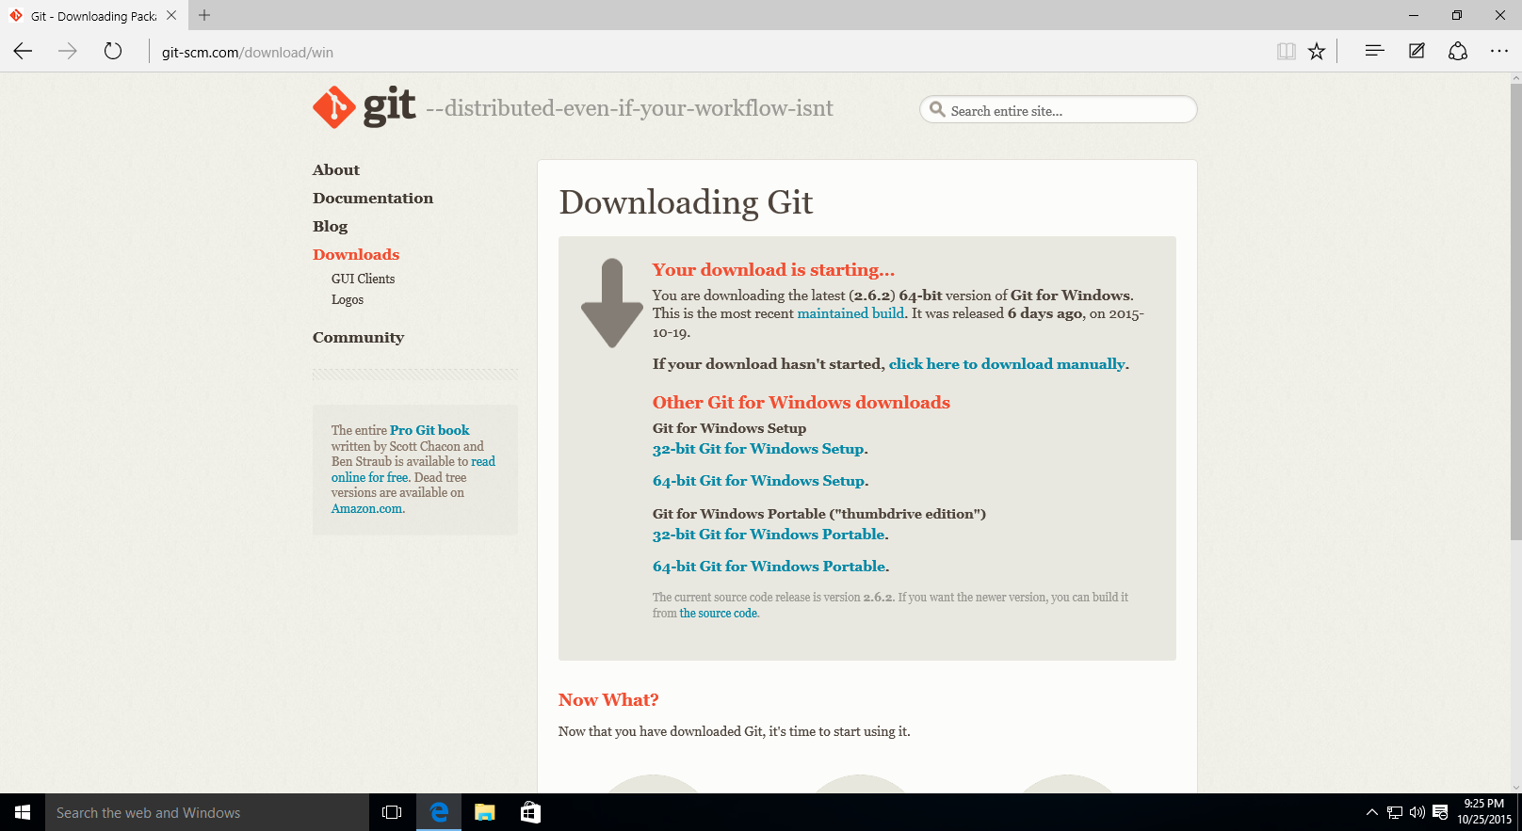
3. Run the file, if prompted by Windows to allow the computer to make modifications, agree by pressing yes.
4. You will be shown this screen. Click Next.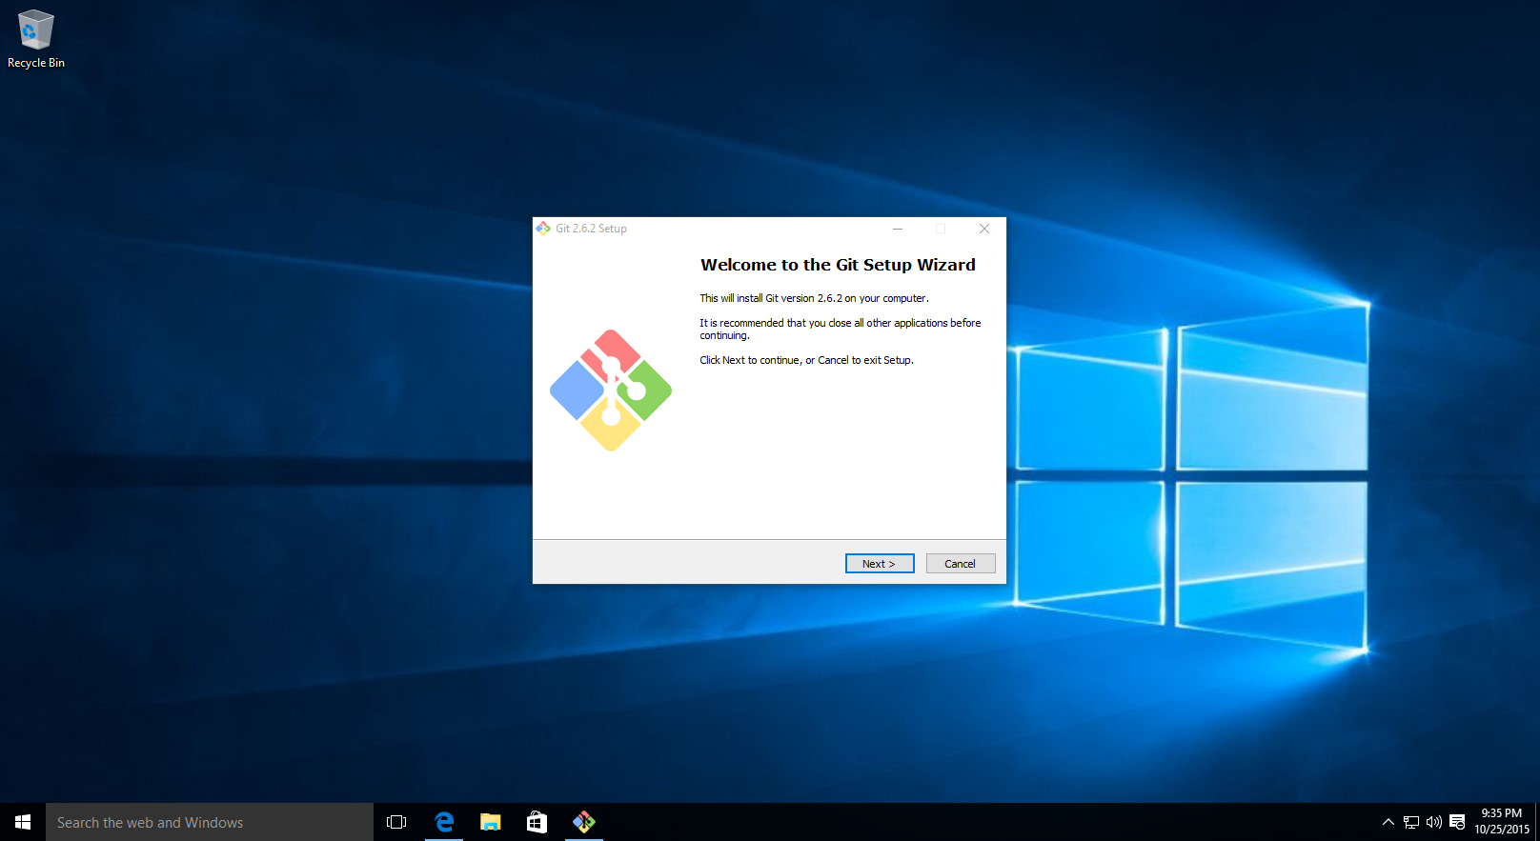
5. Click next to accept the license. 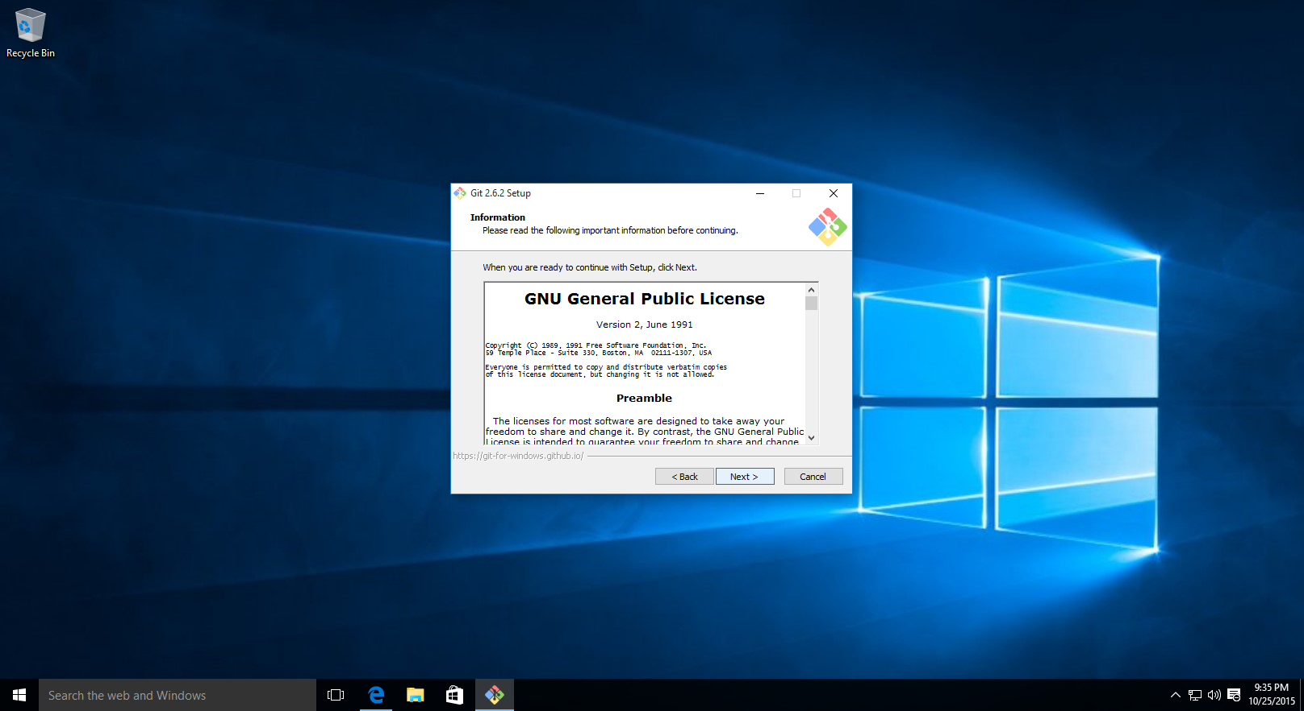
6. Browse to the desired directory to install (or keep the defaults) and press next. 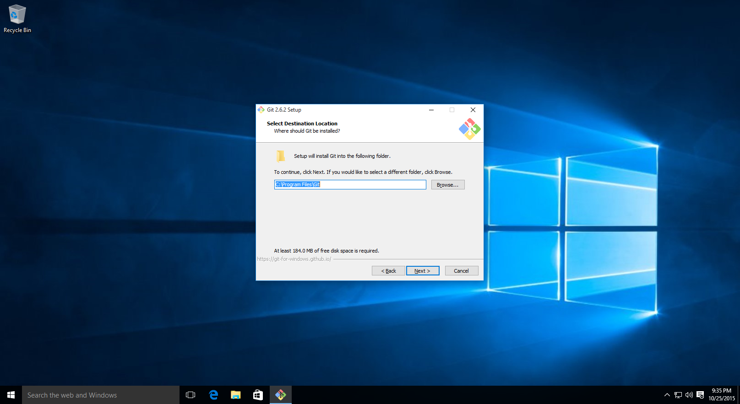
7. Keep the defaults, and press next. 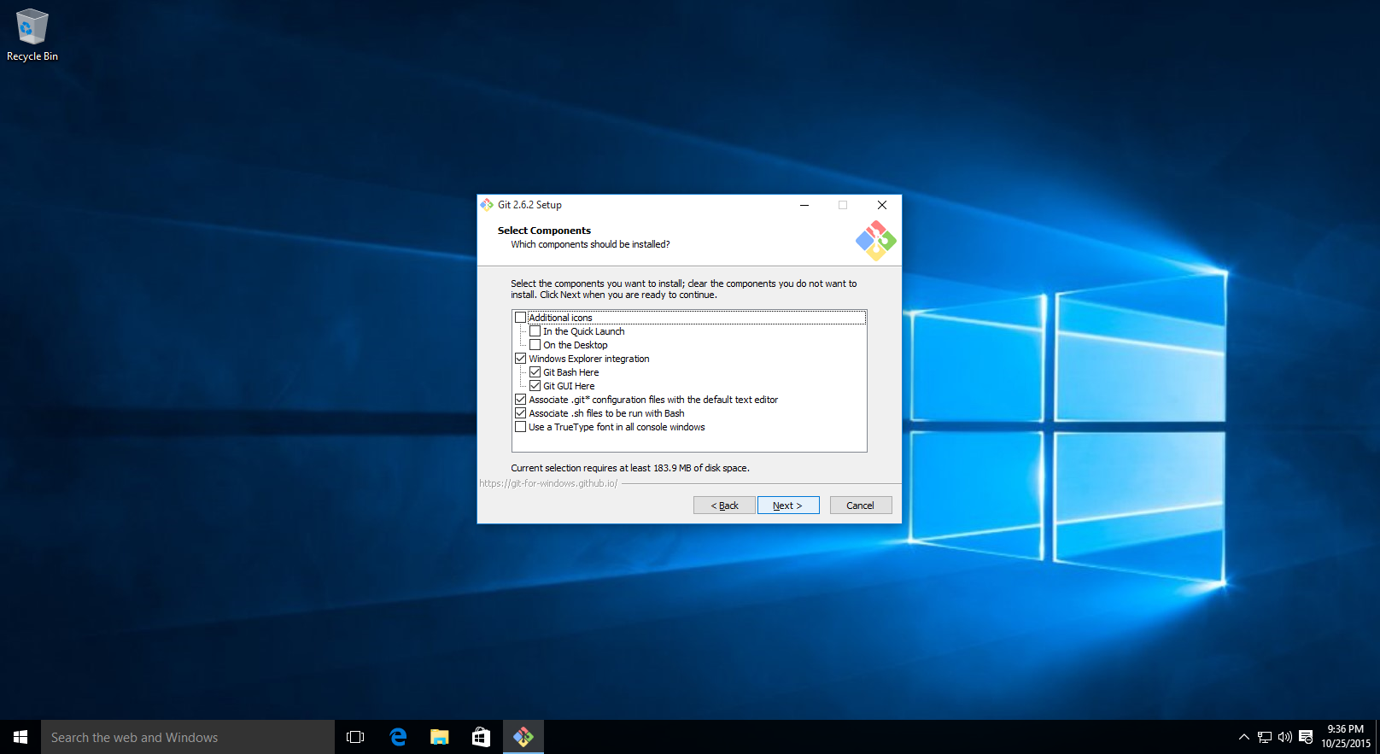
8. Select the desired folder name in the Start Menu and press Next. 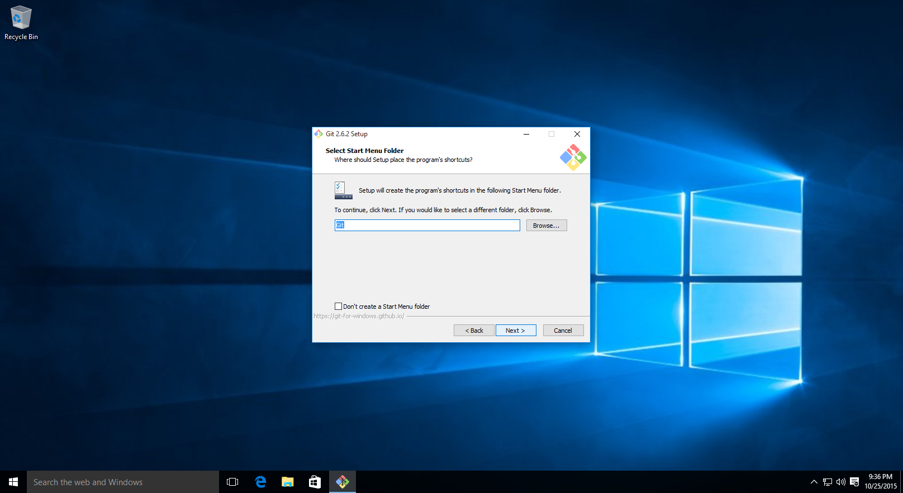
9. Keep the defaults, and press next.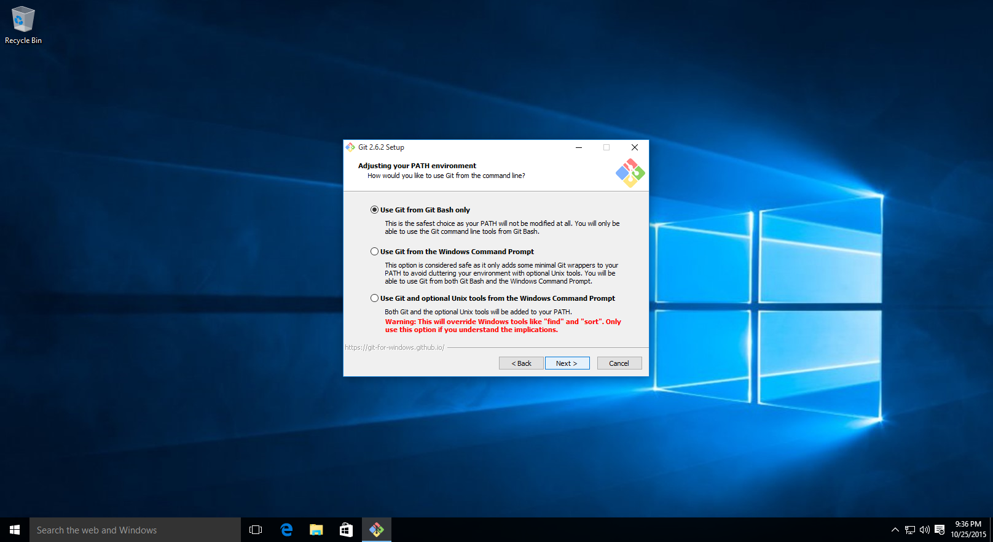
10. Keep the defaults, and press next.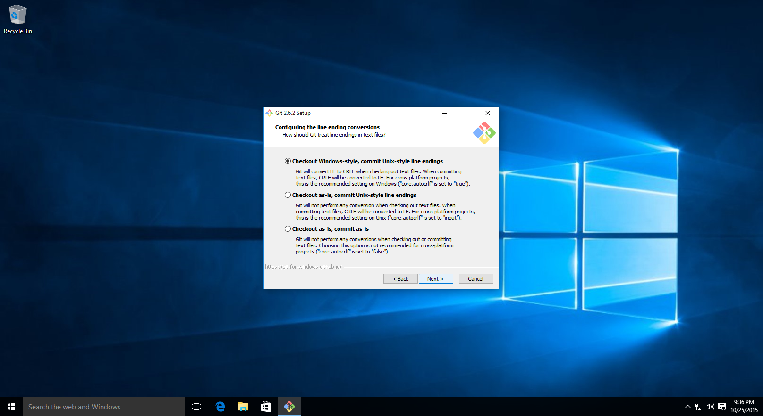
11. Keep the defaults as MinTTY and press next. 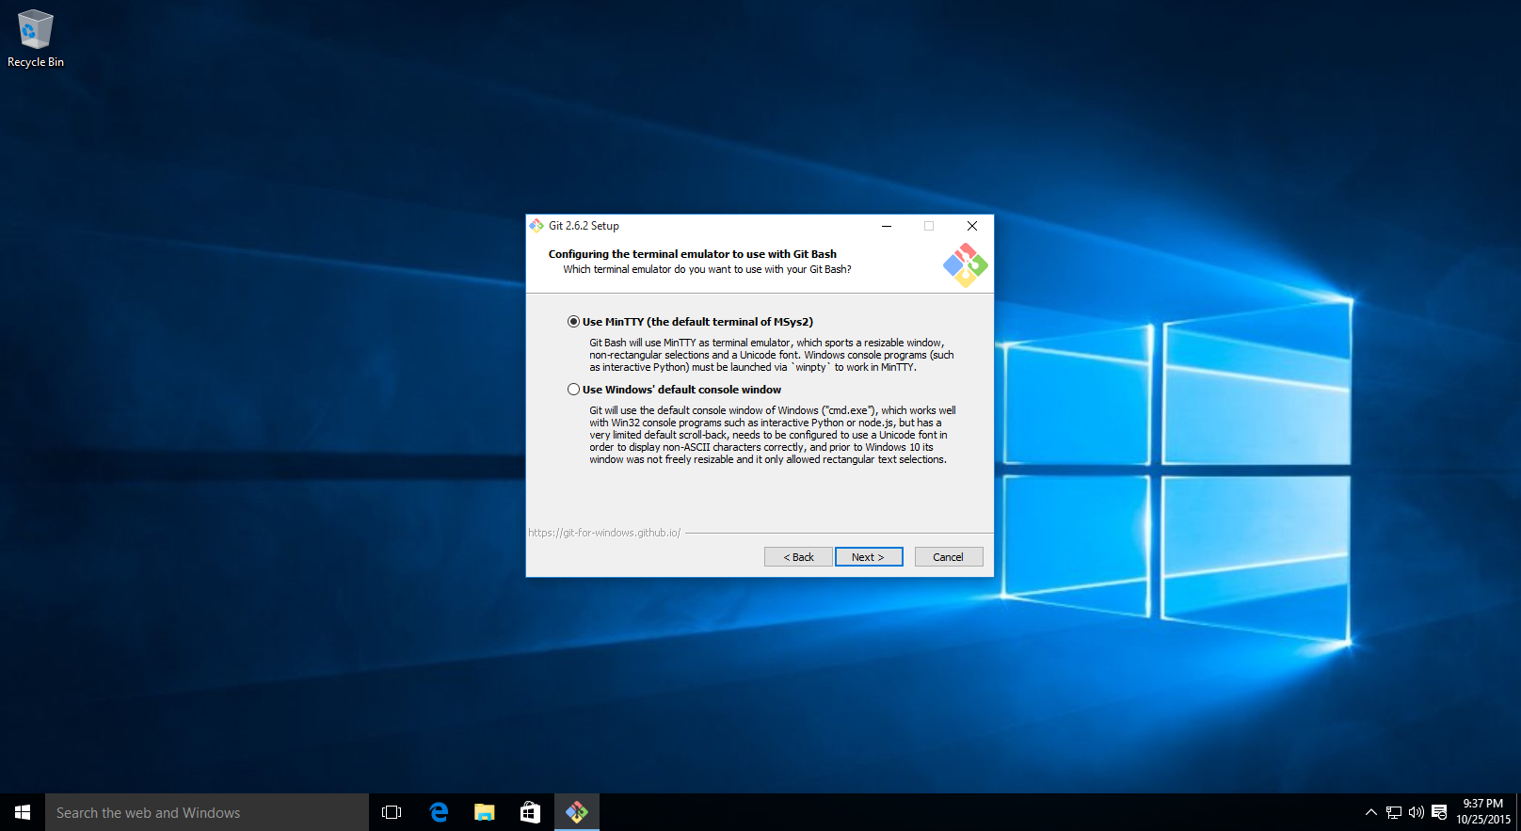
12. Keep the defaults and press next.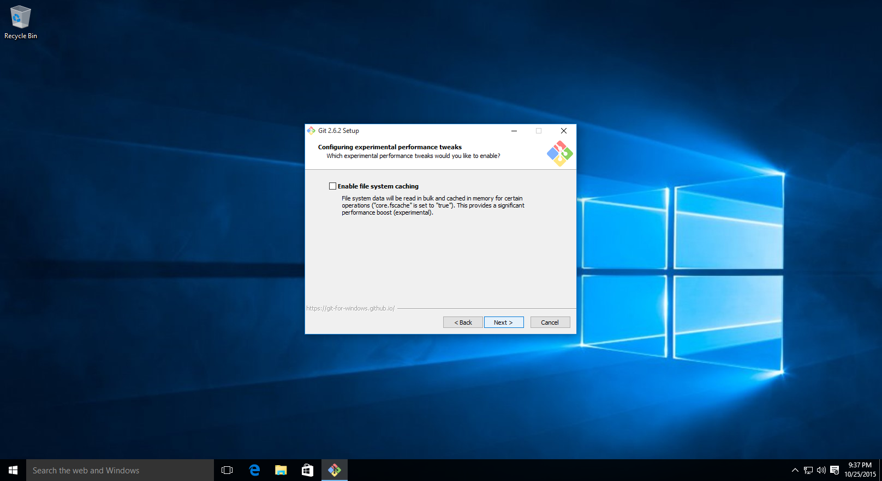
13. Wait for the installation to complete.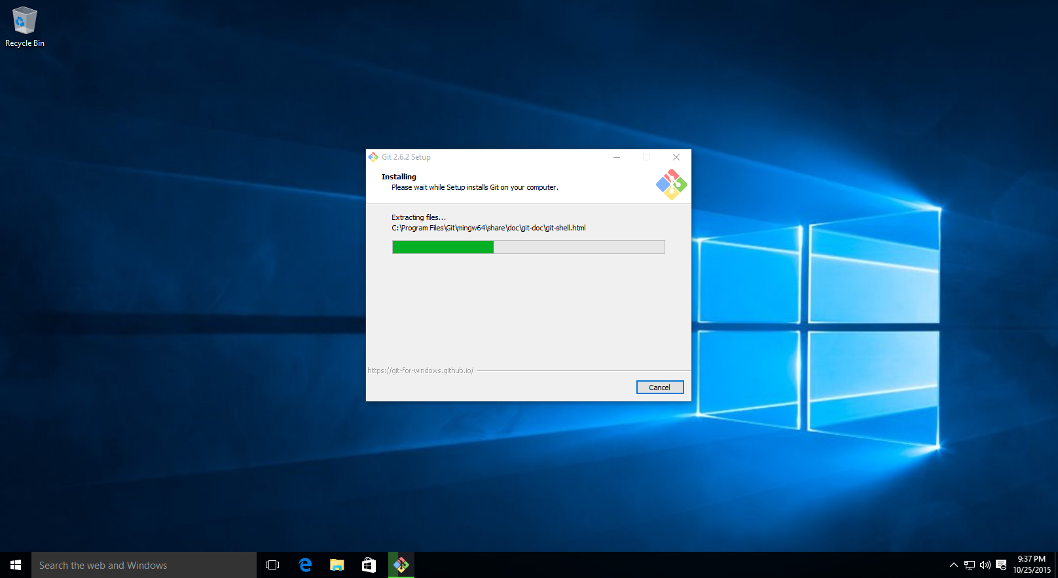
14. Untick the option and press finish.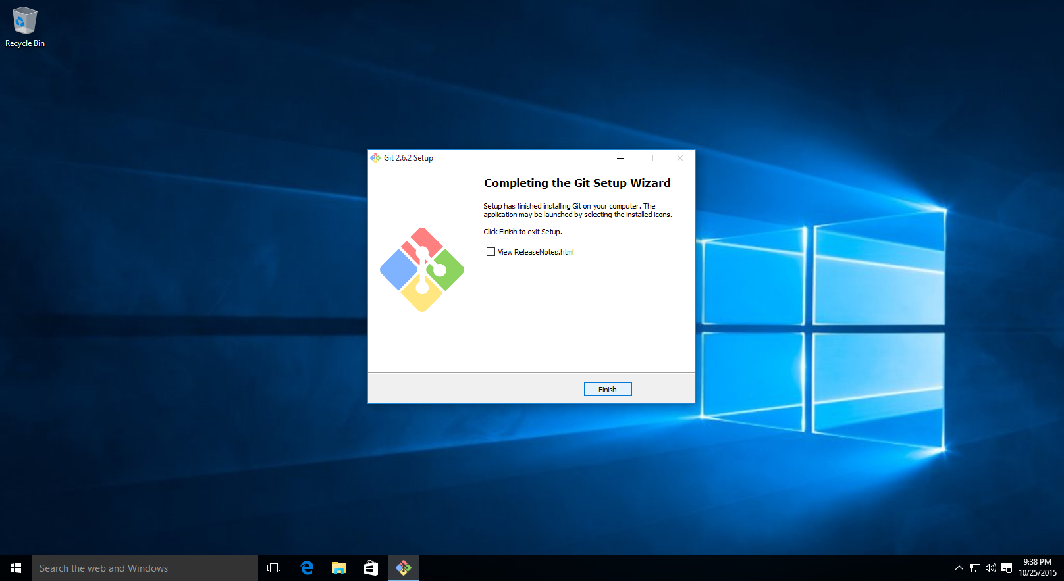
15. Navigate your browser to aws.amazon.com and click on create an AWS Account or login.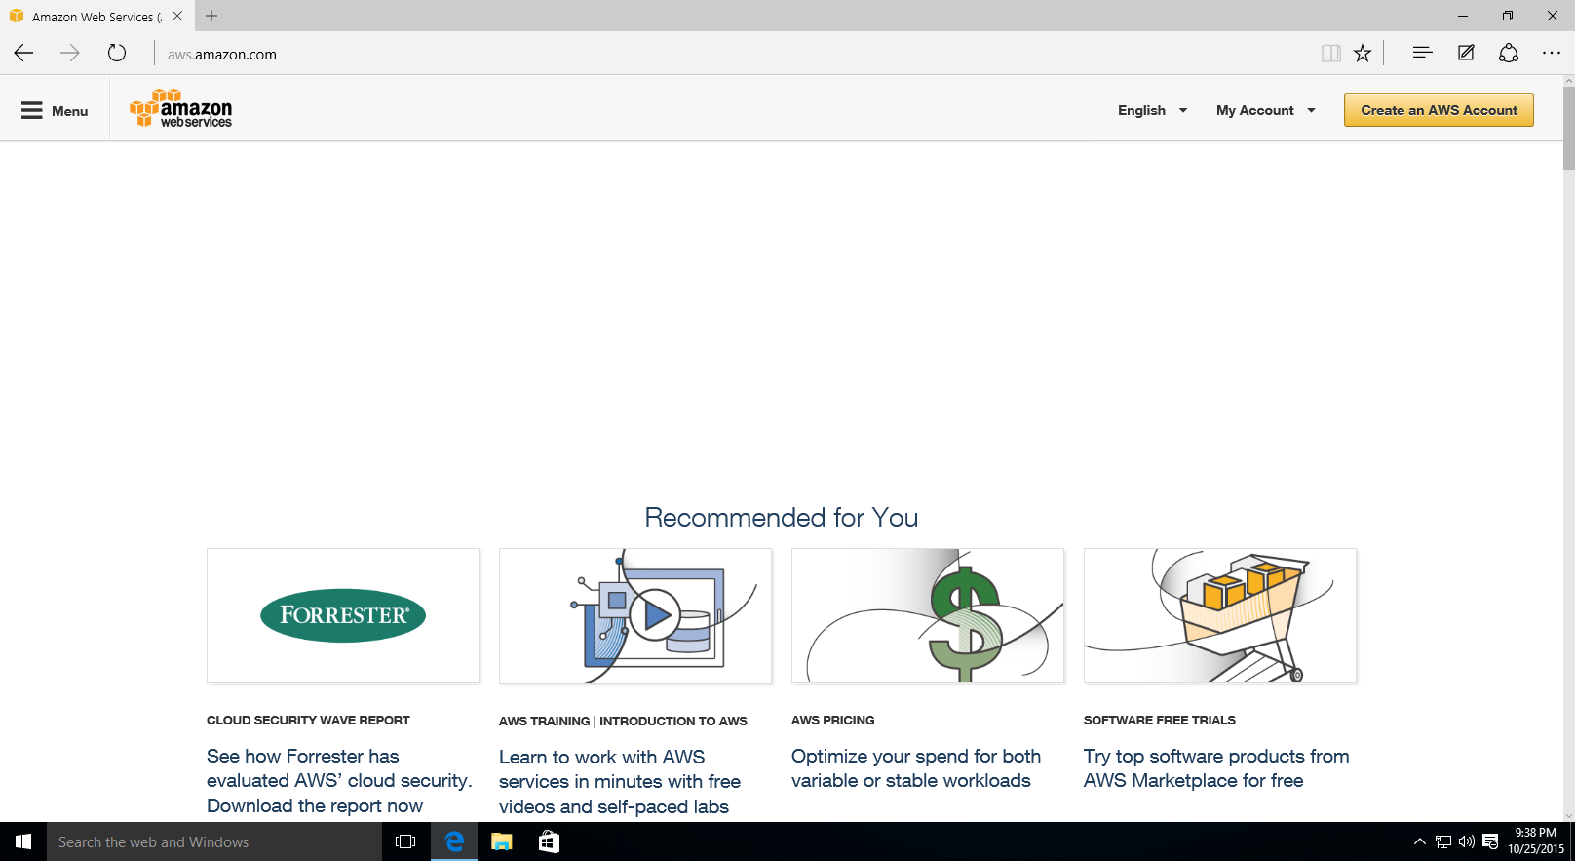
16. Key in your details on the left side and press sign in. 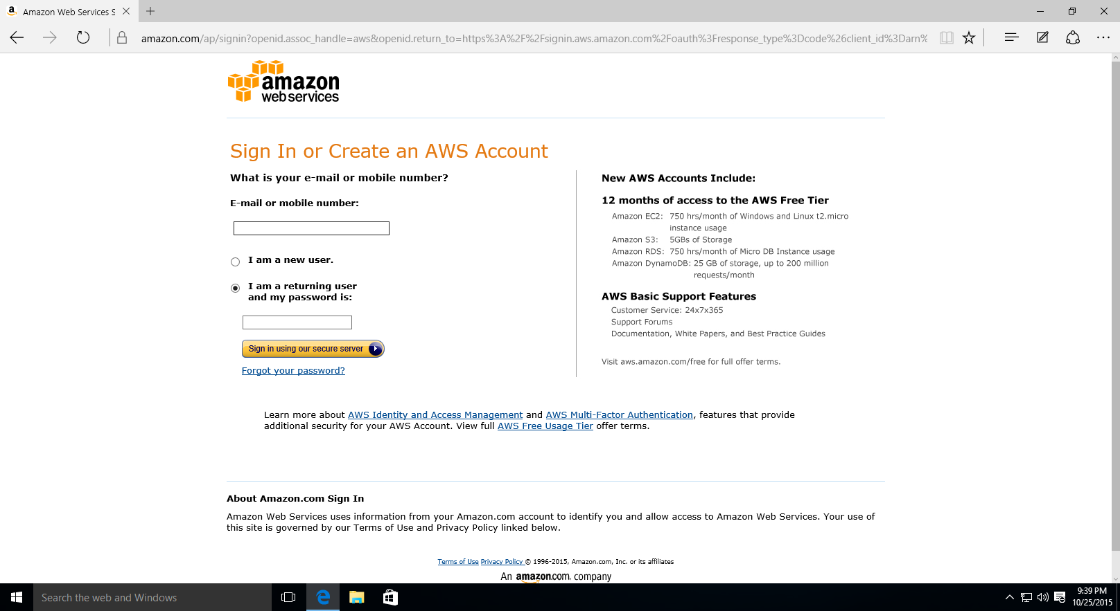
17. Once logged in, click on EC2. 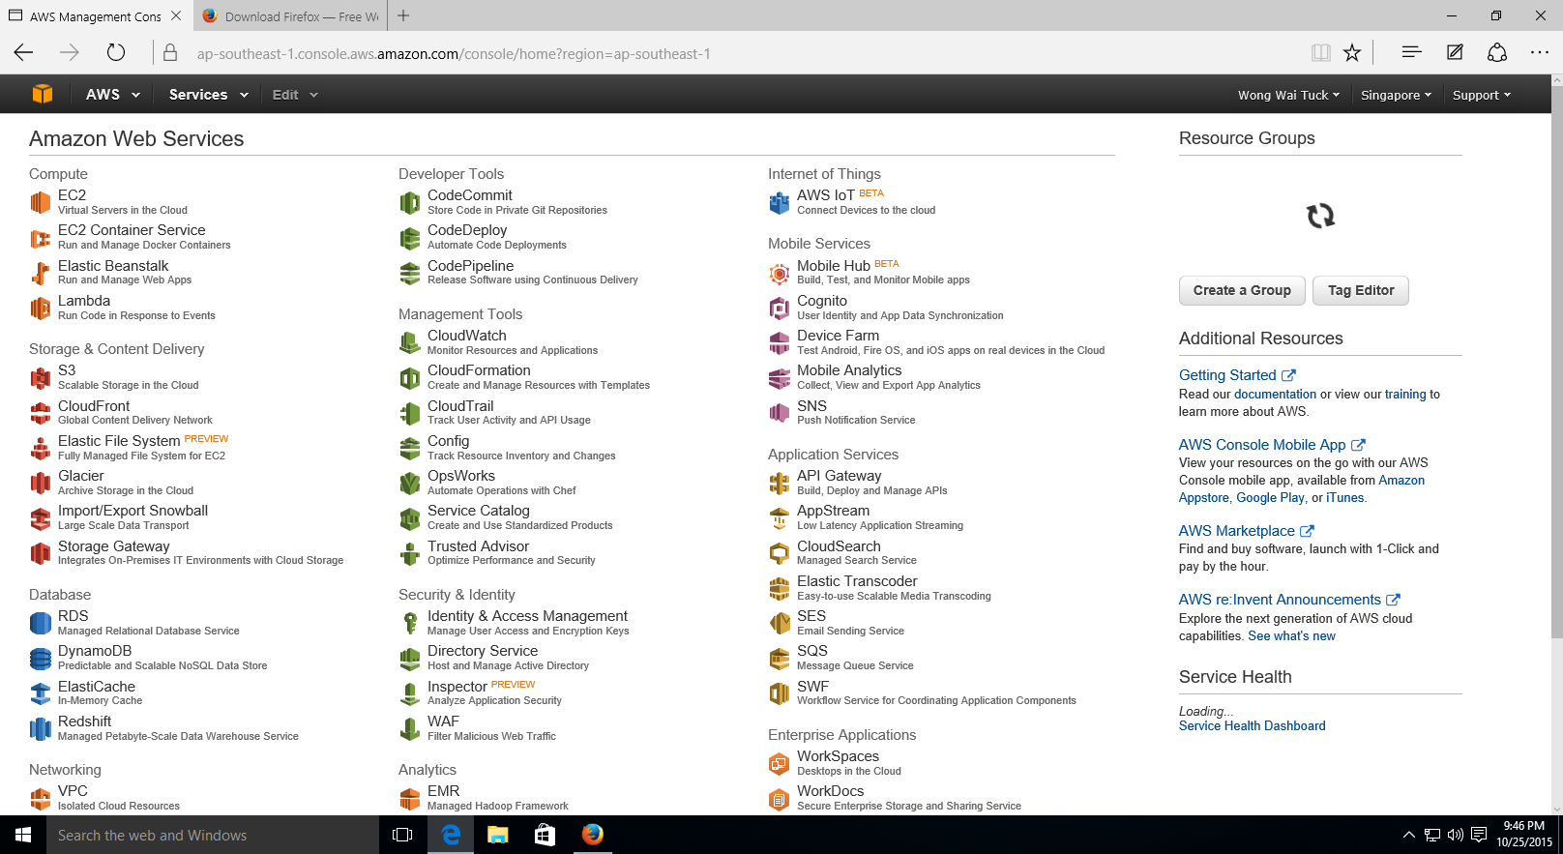
18. Once you click on EC2, you will arrive on this page. Click on Instances on left navigation bar. 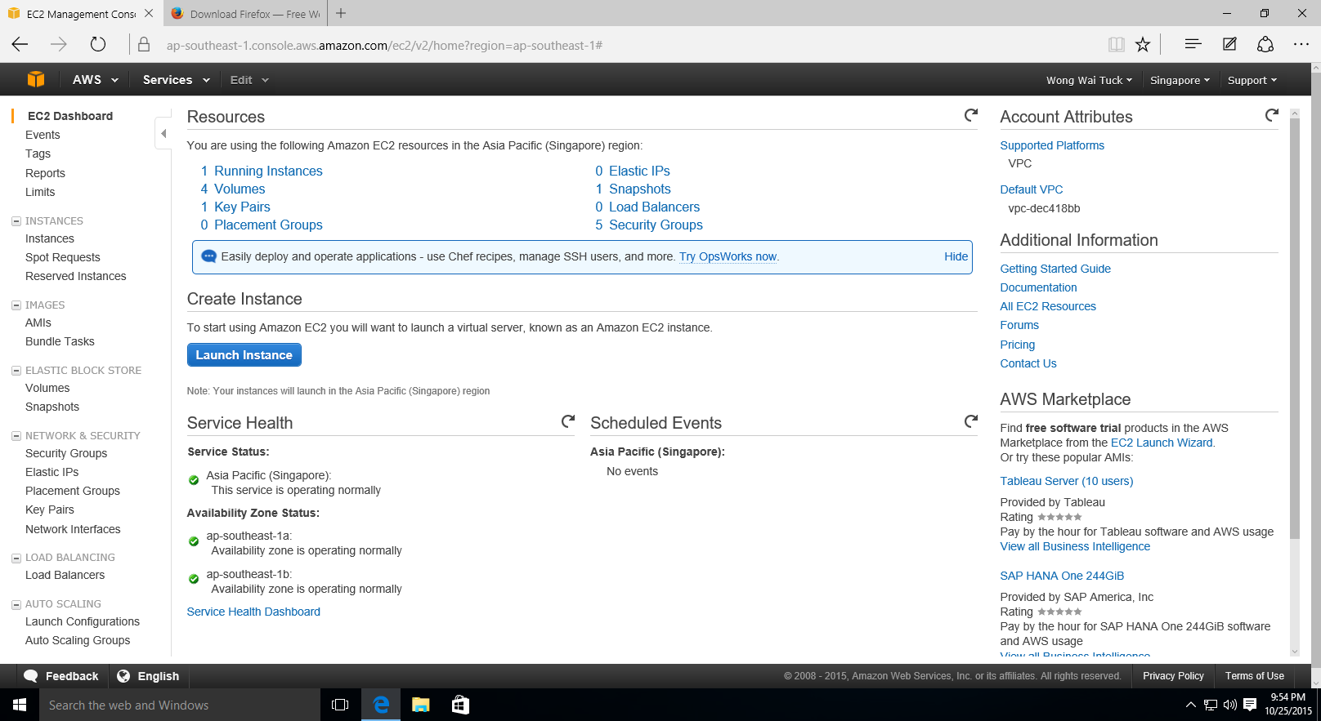
19. Start an existing instance (as shown below). Alternatively, you may create a new instance. Ensure you have the key (.pem file) for the instance! You will need it later. 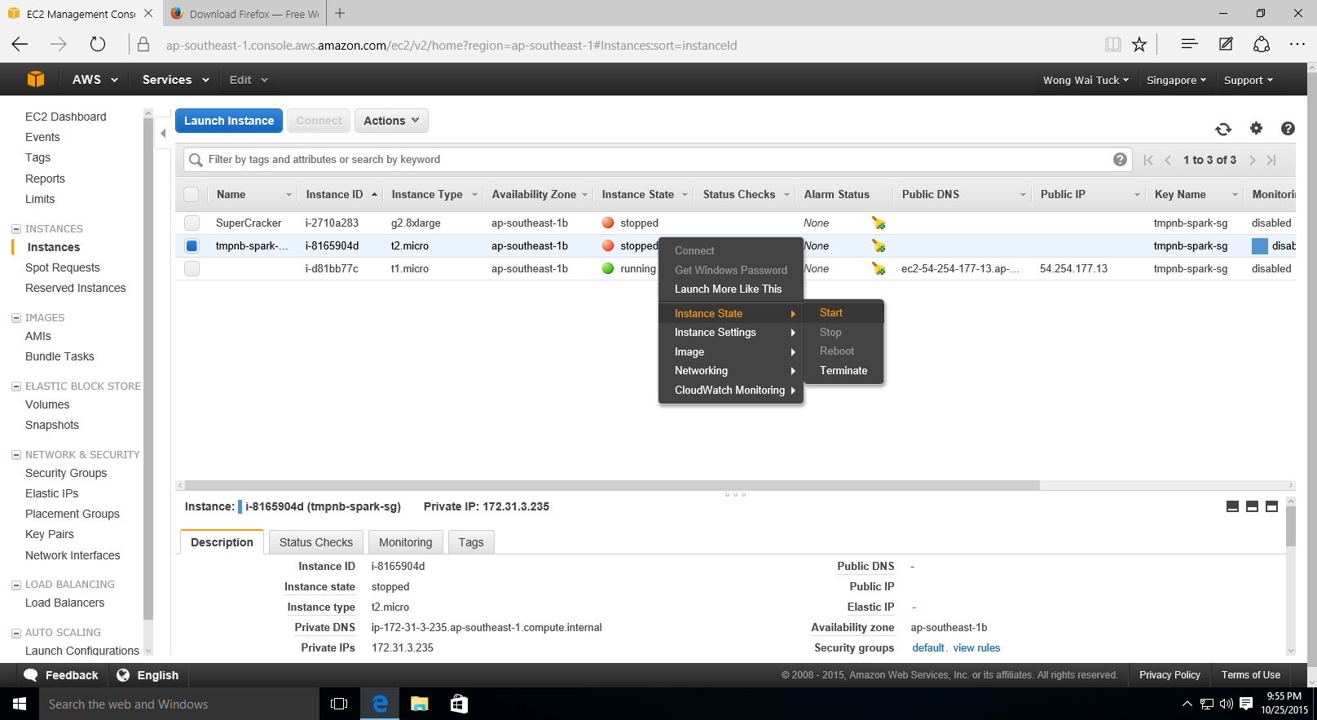
20. Start the instance.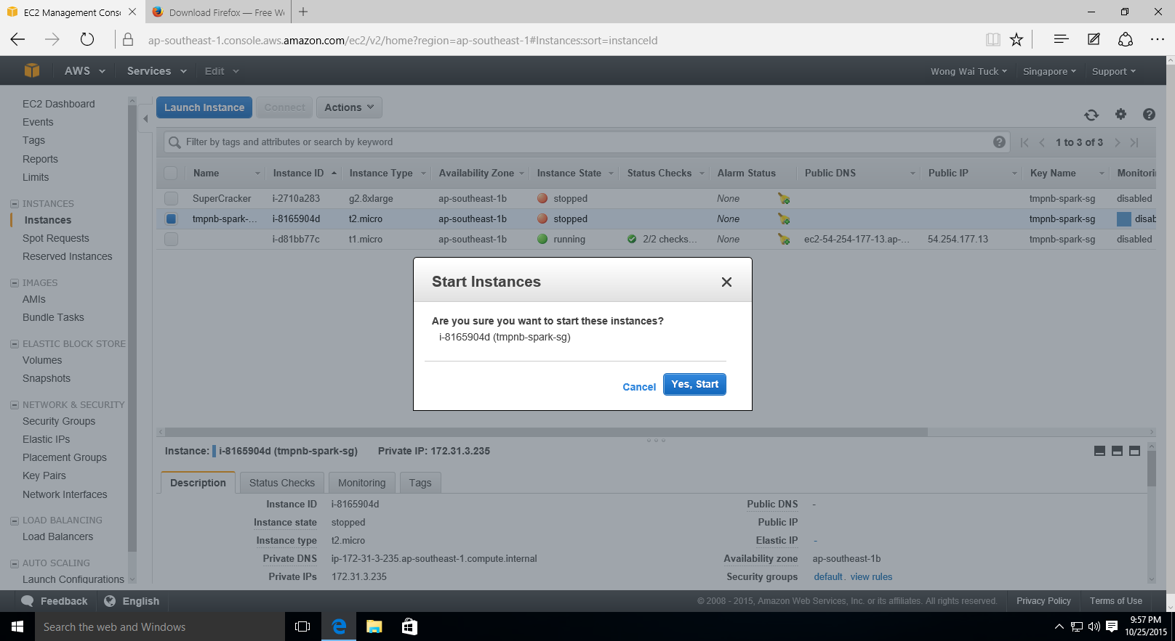
21. Right click on the instance and press Connect. 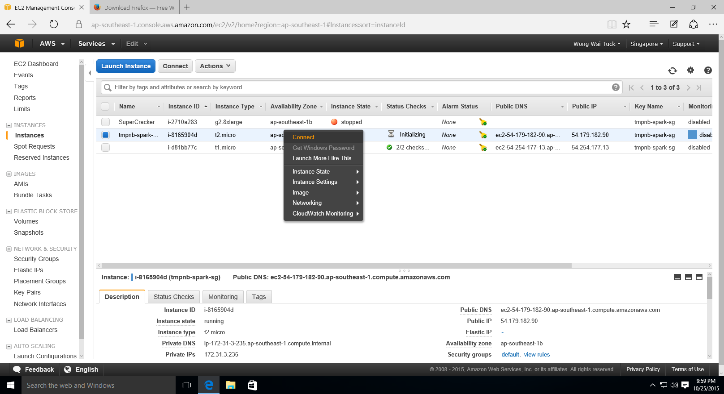
22. Once you press connect, you will be greeted with this screen. Take note of the highlighted area (below) (it should go like ssh –i …) and copy it (Ctrl + C).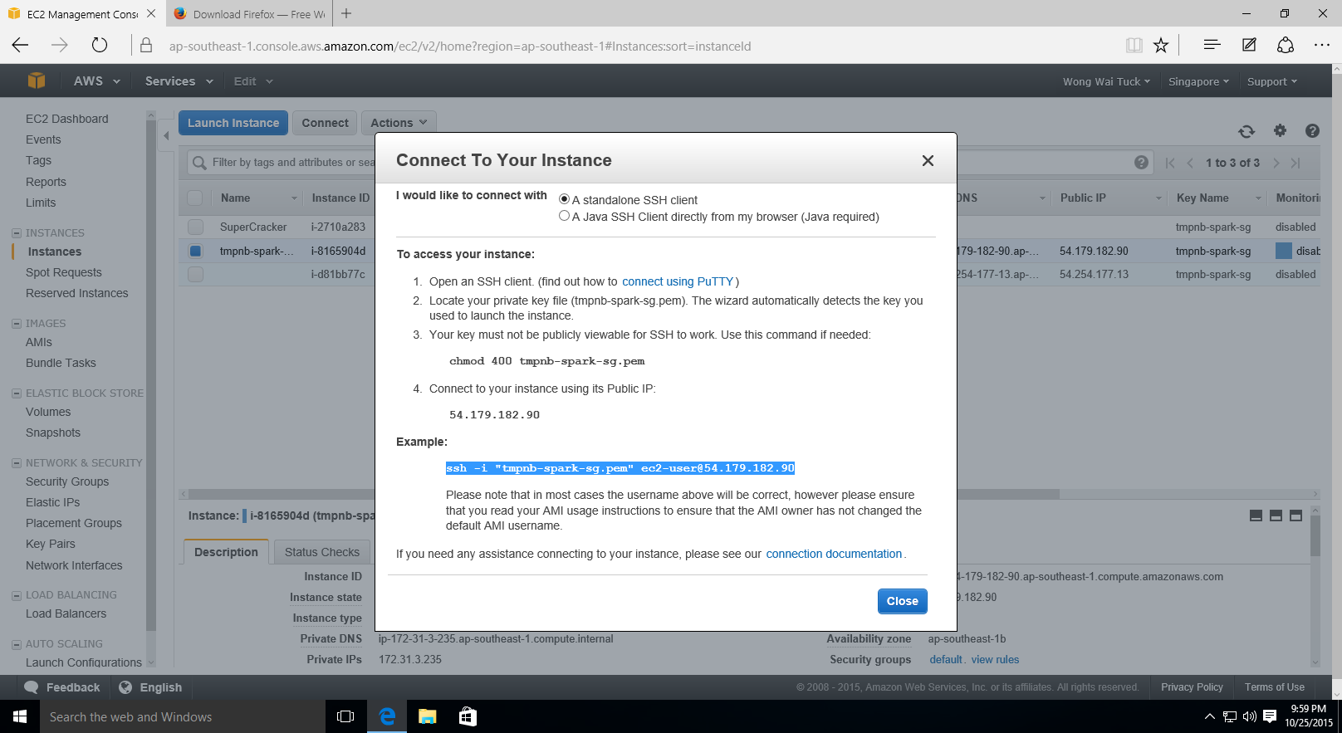
23. In Windows Explorer, navigate to the folder where the pem file for the instance is stored. Right click and press Git Bash here.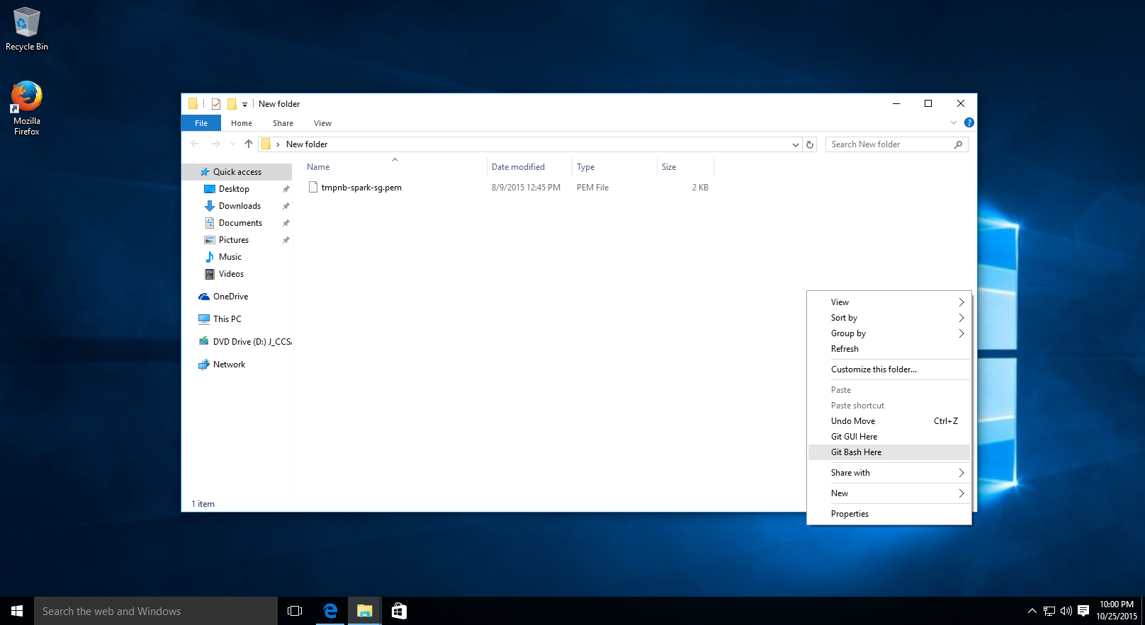
24. Paste the command in the window and press enter. If prompted, type yes and press enter. 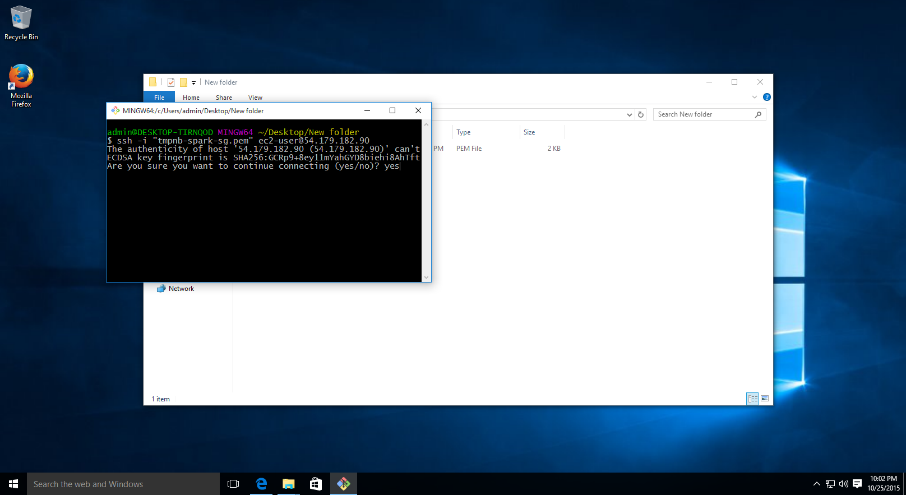
25. If the key is correct, it’ll work as follows and you’ll be logged in to your AWS instance.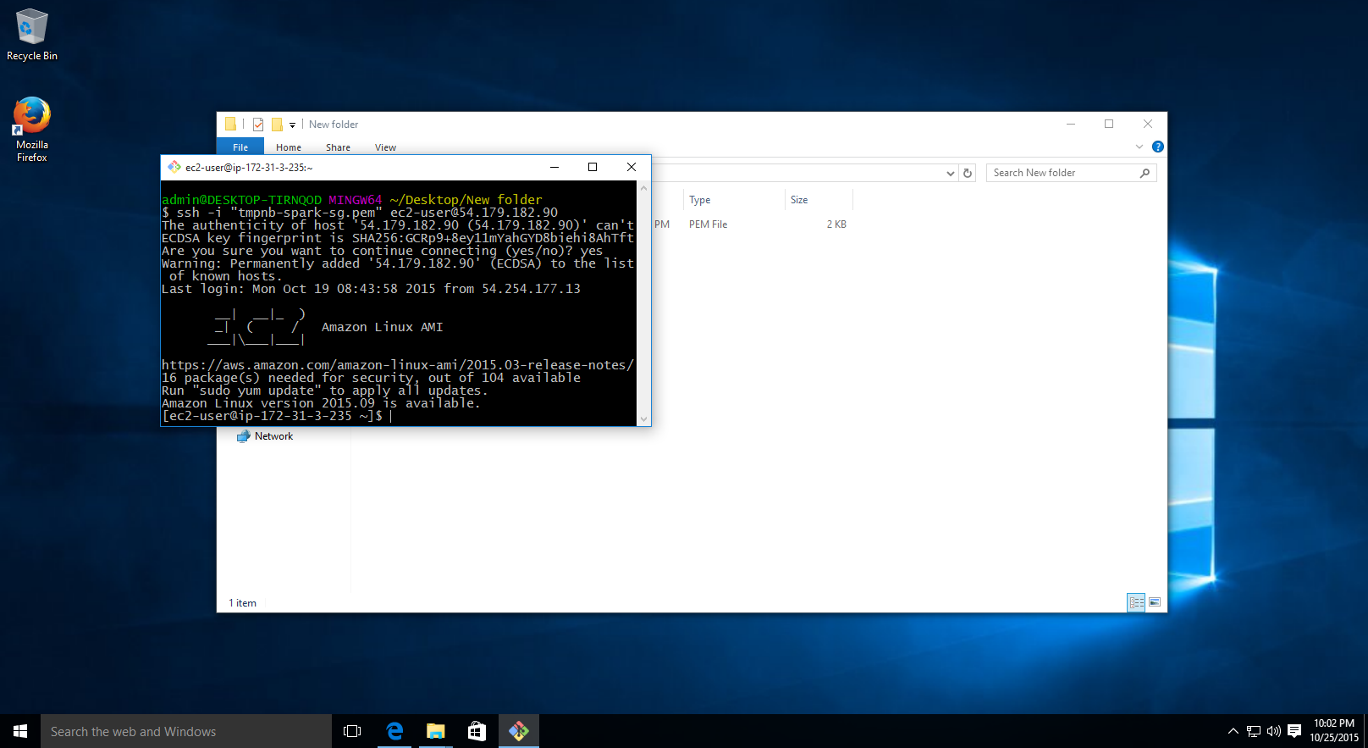
26. You are done!